FIELD SET UP

- Inspect and remove debris from the field. Make sure the field is safe to play

- Fill holes in the pitching mound

- Drag the infield with Drag mat or rake
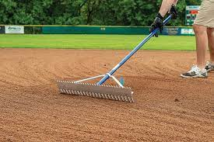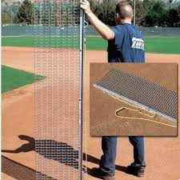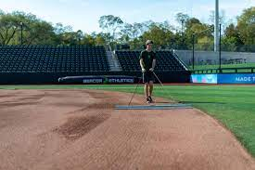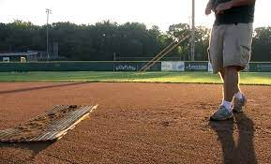
-Start from the middle. Go around in a circle and out.
LL field: drag mat and rake are located in the shed next to the snack shack
Softball field: drag mat and rake are located in the shed between the bathrooms.

- Water the field

Softball field: Use the field irrigation pipe

STEP 1: Take the lid off (usually located by the pitcher’s mound)
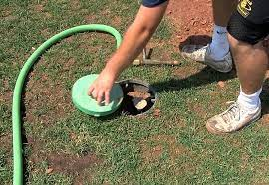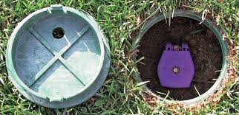

STEP 2: Lift the colored lid. Insert field irrigation pipe. Slowly rotate pipe and water will start (irrigation pipe can be found in the shed in between the bathrooms. Pipe should be stored in a bucket)
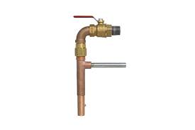

LL field: Use the hose reel (located in or around the shed next to the snack shack)

STEPS: Pull hose reel to the field, plug into irrigation pipe, spray the field
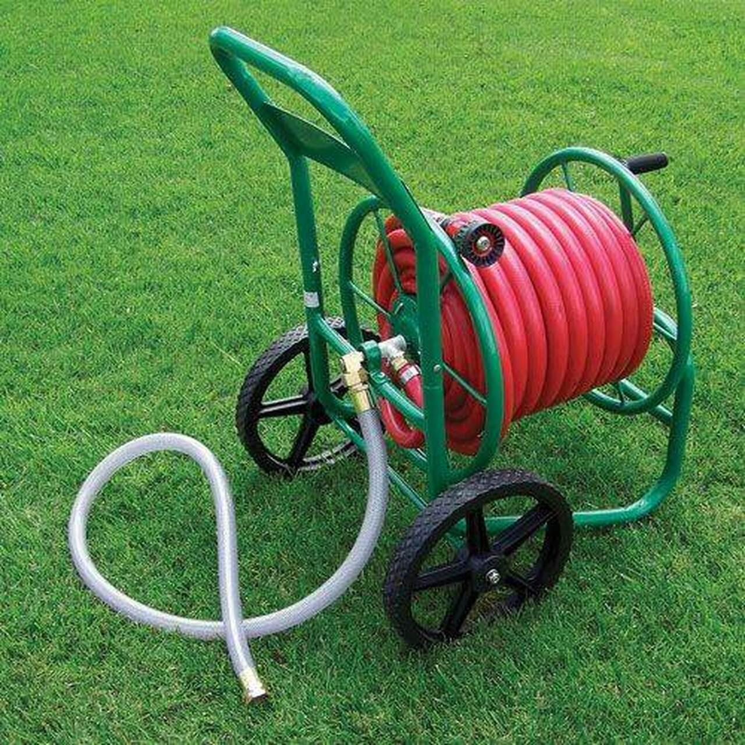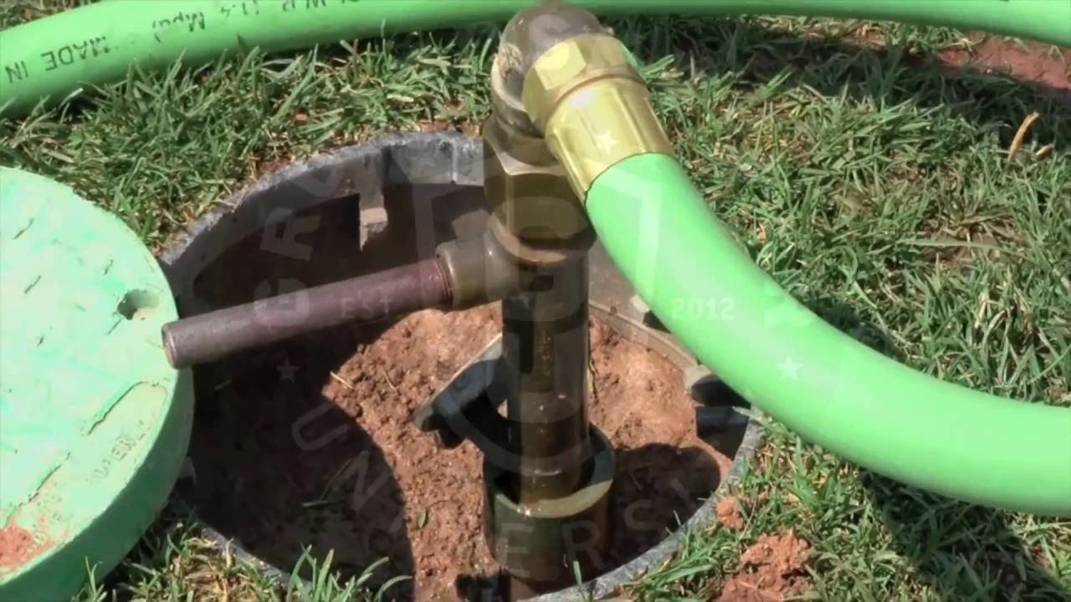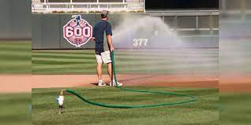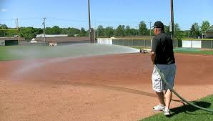

- Chalk the lines on the field
STEP 1: Open the top of the chalk liner cart and fill with chalk
(LL field: chalk and chalk liner cart are located inside the shed next to the snack shack.
Softball field: chalk and chalk liner are located inside the shed between the bathrooms)

***Chalk liner cart needs to be set to number 2
***Make sure to use the chalk liner cart. Spray paint cart is only to be used on the grass.

Chalk 
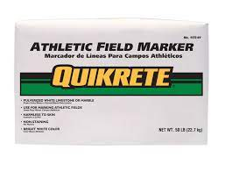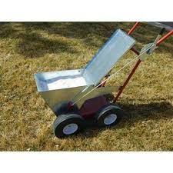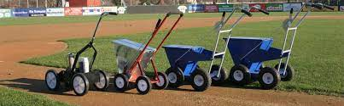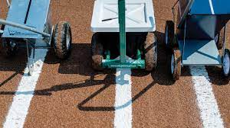

STEP 2: Get template and line it up with home plate. Lightly step on the template to engrave the imprint in the dirt. Take off the template and line the box with the chalker liner cart (Make sure the cart is set to number 2). One box on each side of the plate
LL field: template located on the outside of the shed that is next to the snack shack
Softball field: Template located inside the shed between the bathrooms.

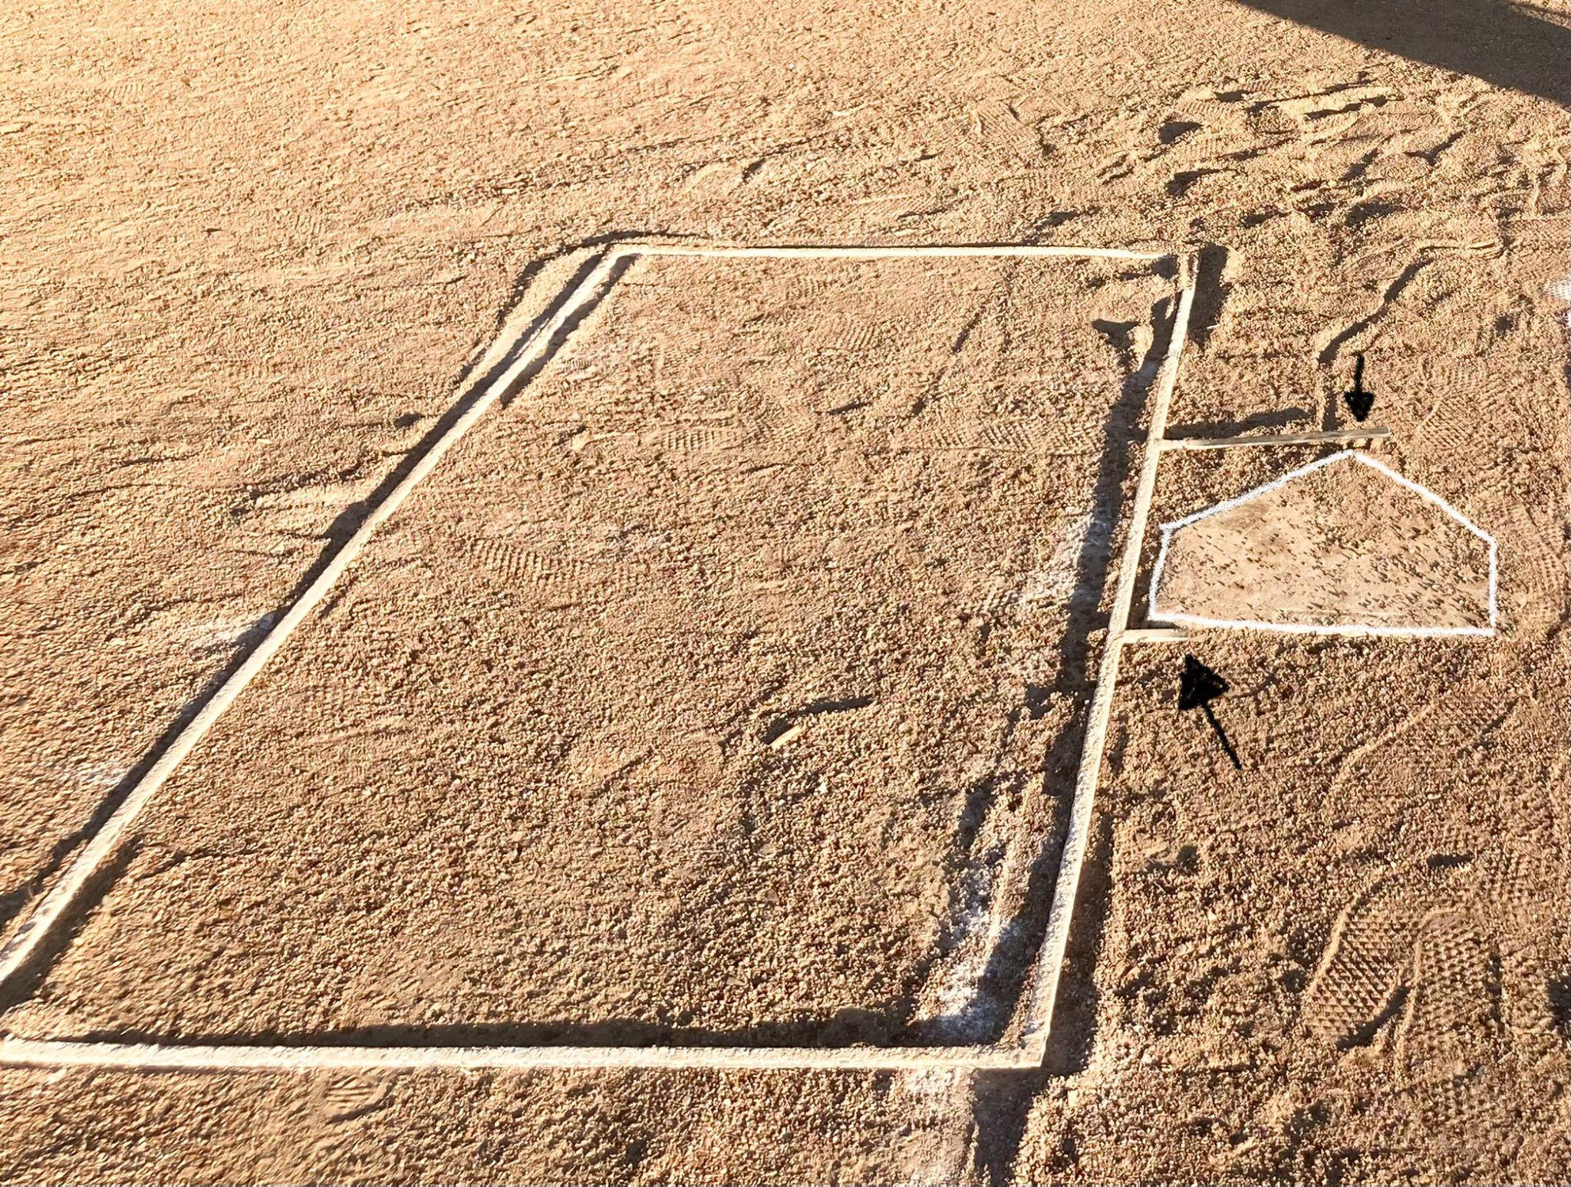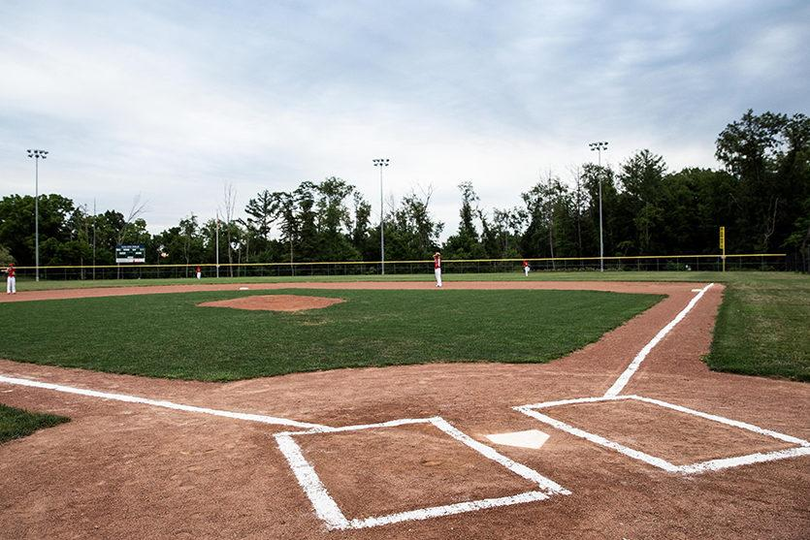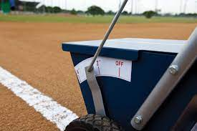

STEP 3: Use rope to make the line from home plate to first base and home plate to third base. (Make sure chalk liner cart is set to number 2)

ROPE (color may vary. LL field: rope located in the shed next to snack shack. Softball field: rope located inside shed between bathrooms.)
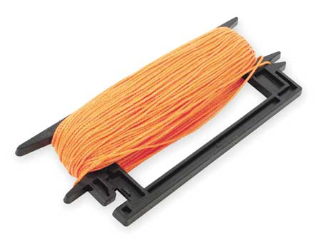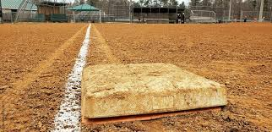

- Set up bases
LL field: located in the shed next to the snack shack
Softball field: located in the shed between both bathrooms.

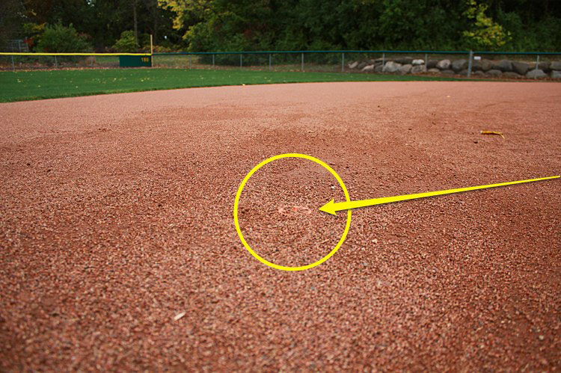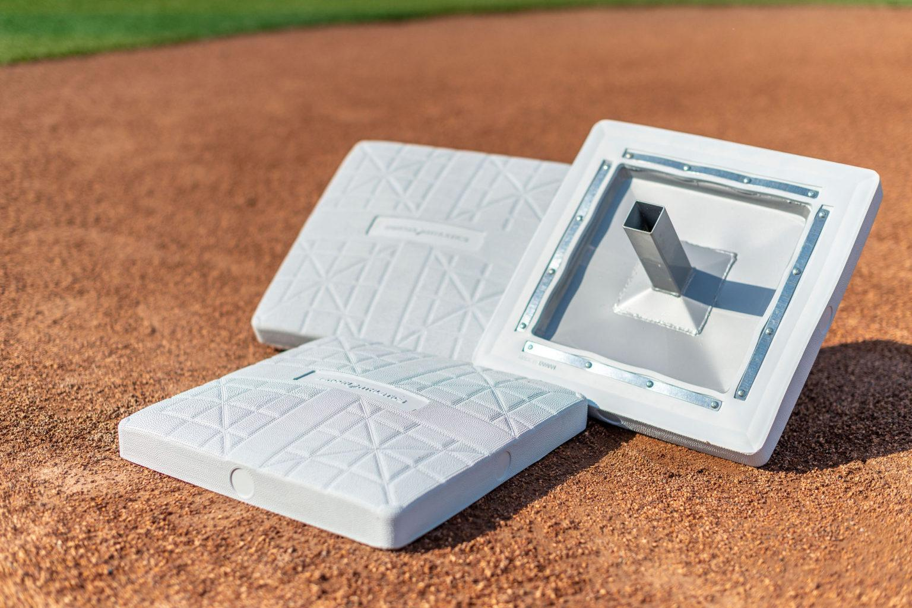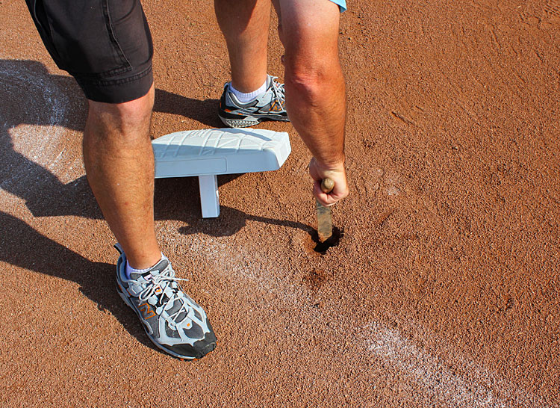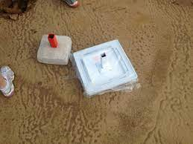
-Sometimes the anchor is hidden by dirt as shown in the first picture. Move away the dirt and fit the base on the anchor like a puzzle piece.

- Hang up the American flag
LL field: flag is located in the snack shack and the pole is near the bathrooms
Softball field: located in the snack shack and the pole is located between the field

- Open snack shack doors (if not already open and make sure someone is there to run it.)

- Open Announcer booth (keys located inside the snack shack: directions for announcer booth are located inside the booth)

- Turn on the scoreboard (all levels with exception of T-ball, if applicable)

- Unlock bathrooms
LL field: bathrooms are always open
Softball field: keys are in the snack shack

FIELD CLEAN UP
Divisions AA+ need to assist with field clean-up.

1.) Lock bathrooms
LL field: Bathrooms remain open. (Do not lock LL Field bathrooms)
Softball field: Lock bathrooms and put key back in snack shack

2.) Turn off score board

3.) Take down American flag
-take down flag, fold it, and return it back in the snack shack

4.) Put away the bases (Player assisted)
LL field: Return to the shed next to the snack shack
Softball field: Return to the shed between both bathrooms.

5.) Clean up field and dugouts (Player assisted)
-get rid of any trash in both the dugout and on the field

6.) Drag the infield (or rake) (Player assisted)
-drag the field to prep for the next game, if needed

7.) Close and lock the announcer booth & Equipment Sheds
-Be sure the announcer puts things back to their original places, make sure lights are off, be sure the door is locked

8.) Closing the snack shack
-The snack shack volunteer will do the clean-up, but be sure to get all the trash out of the snack shack
-Empty ALL trash: snack shack trash, trash from field and dugout, trash in larger trash cans and put them in the dumpster.

